Challenge 2 Screenshots

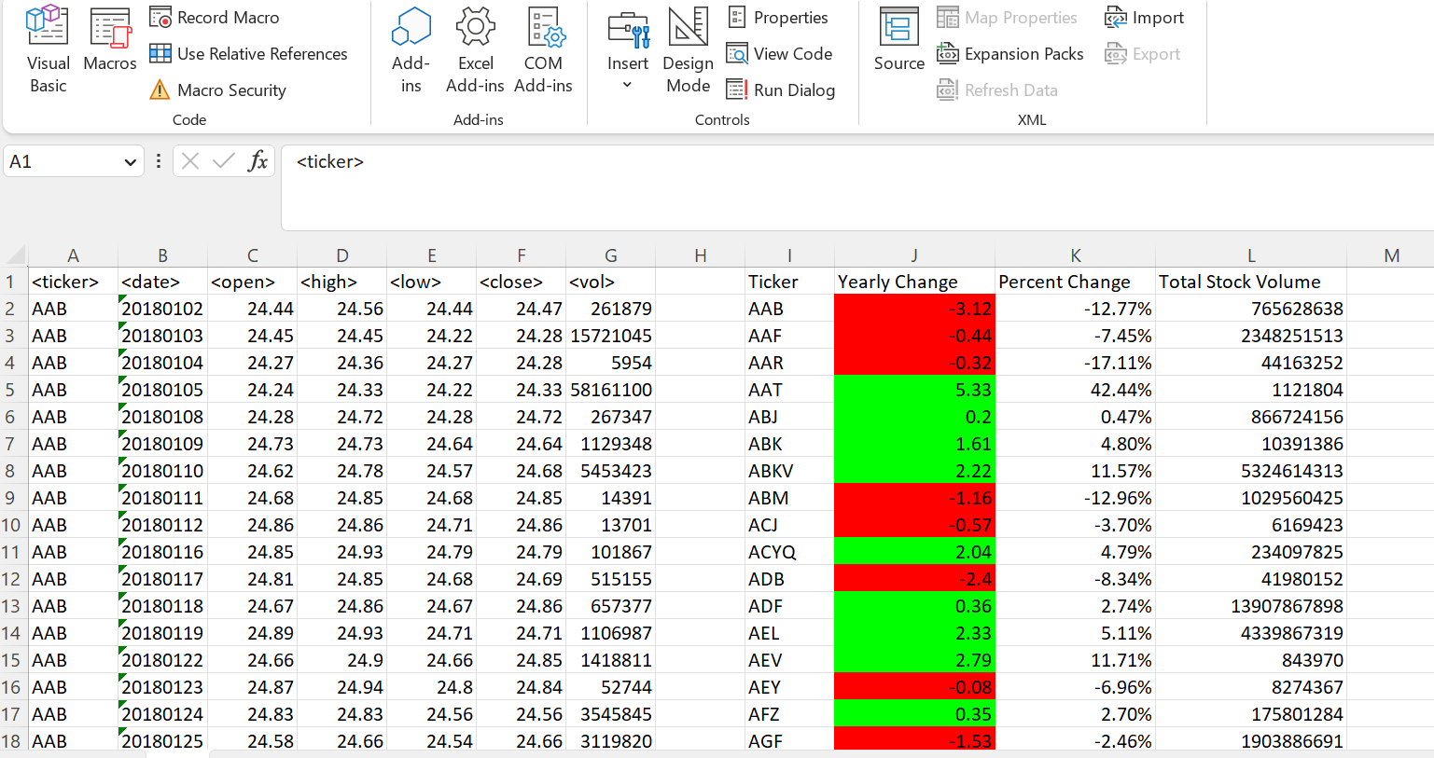2018 Data

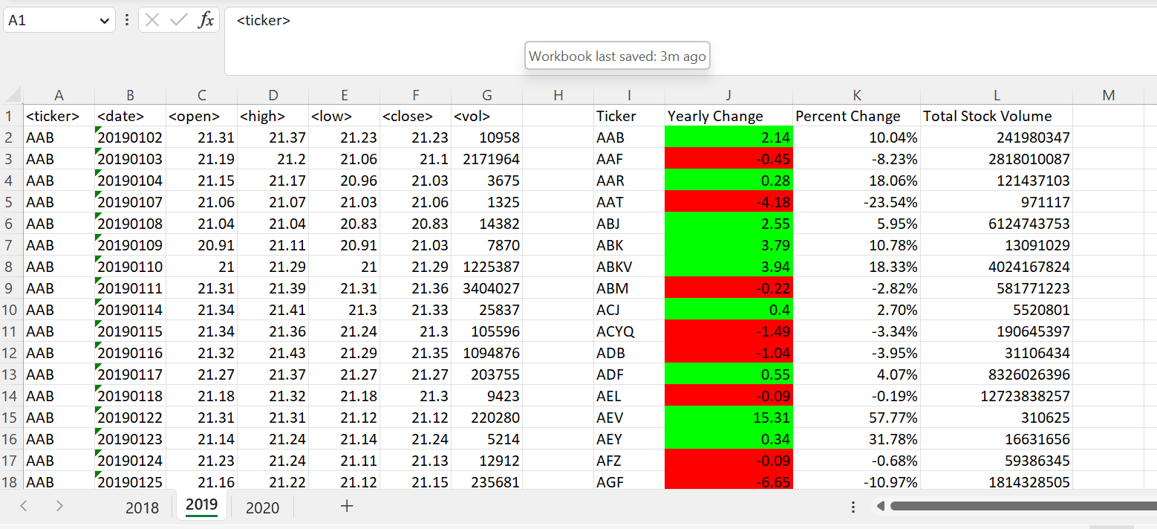2019 Data

2020 Data

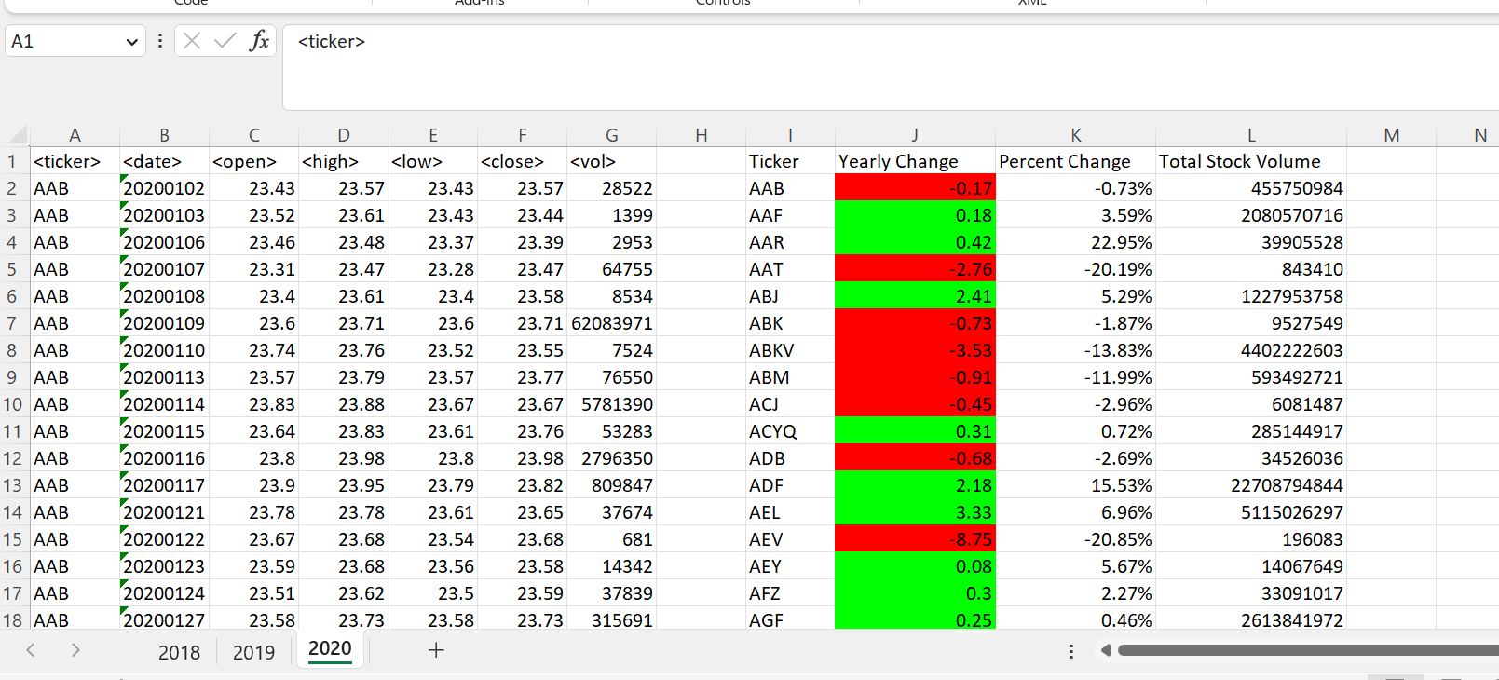

Bonus

2018

2019

2020

